Steps To Install Allure In Eclipse

1. First I have created a simple maven Project in Eclipse.

2. We have to add The required Maven Dependencies in pom.xmlfrom[**https://mvnrepository.com/**](https://mvnrepository.com/) **(Maven Repository)**

3. Next we have to add Allure&TestNG dependency Latest version from Maven repository

**<dependency>**

**<groupId>io.qameta.allure</groupId>**

**<artifactId>allure-testng</artifactId>**

**<version>2.20.1</version>**

**</dependency>**

4. Next we have to download Maven and allure binaries then set path by manually in windows

* Maven

**. WebPage -** [**https://maven.apache.org/download.cgi**](https://maven.apache.org/download.cgi)

. We have to select Binary Zip archive file download

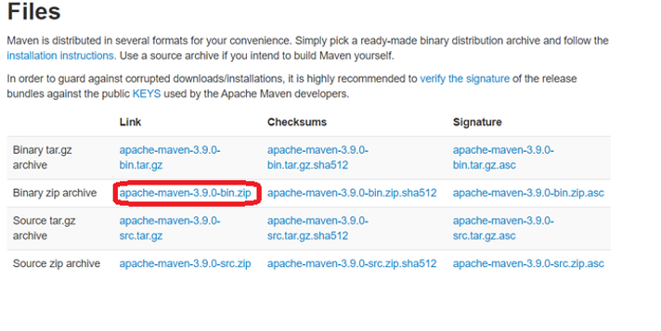

. Extract the zip file and stored it in our local system.

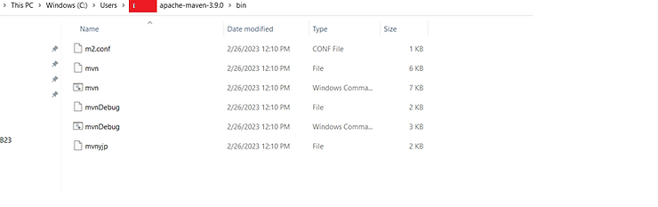

. Set Path in Environment variables

. Then we have to cross check maven version in windows command prompt by giving **mvn – version**

*Allure

**. Web Page -** [**https://docs.qameta.io/allure/**](https://docs.qameta.io/allure/)

. Select 2.1.Installing a commandline

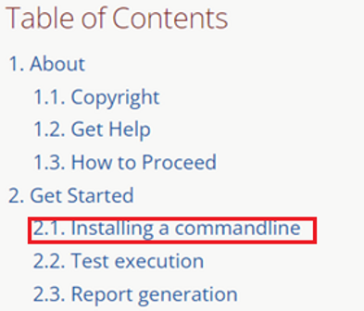

. In 2.1.4 Manual installation click Maven central

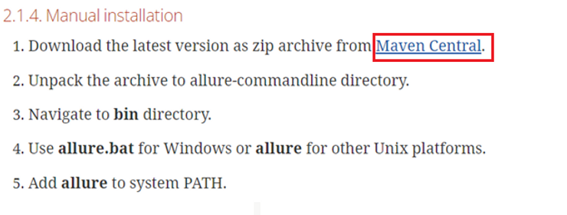

. Multiple versions available there we can select the latest version which one is highlighted

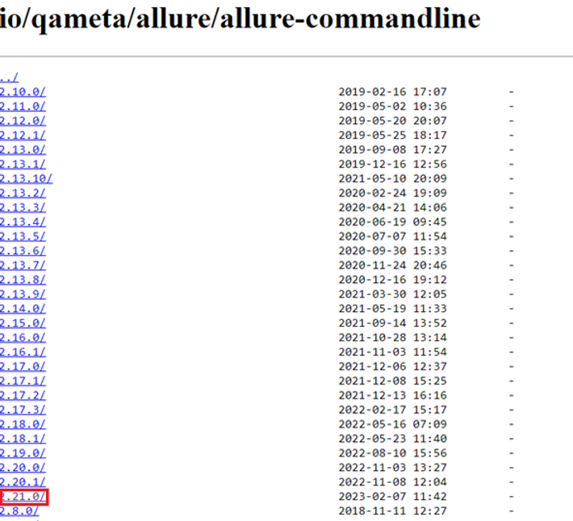

. After downloading this extract the zip file and stored it in our system like same what we did for maven

. Set the path in environment variables

. For cross checking in windows command prompt have to give

**allure - - version**

5. Run the Project in Eclipse.

6. Refresh the Project by right click.

7. Now you can see a folder (allure-results) Should be created In your Project

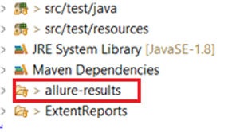

**but results will be in json file**

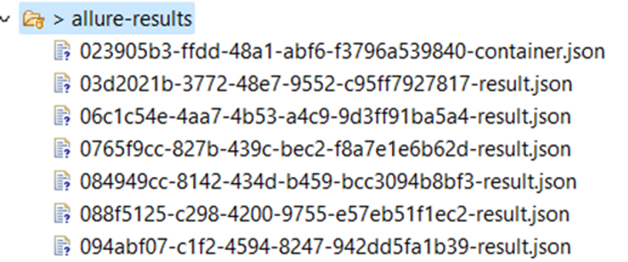

8. For creating Allure- Reports

. Right click allure-results and get Properties folder path , copy it

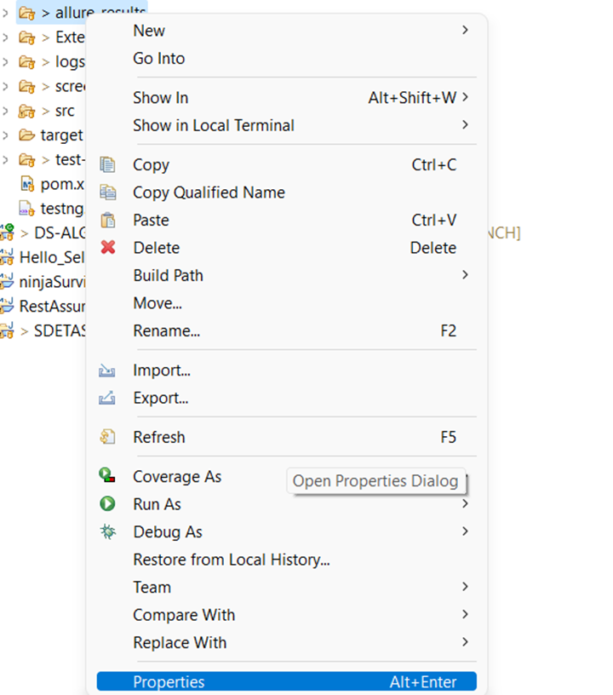

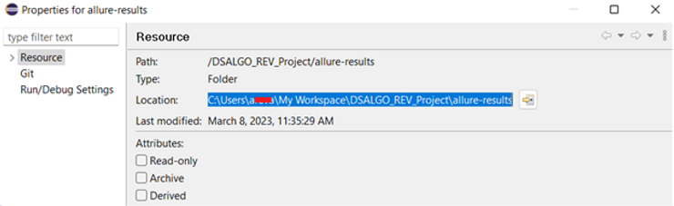

9. In windows command Prompt

Type : allure serve “Paste Properties folder path” and press enter

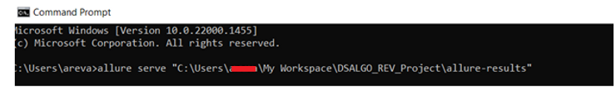

10. It will re-route to a new Page there we can see allure Report . We can easily find all the test cases results by these views.

Allure Report Dashboard

The overview page hosts several default widgets representing the basic characteristics of your project and test environment.

**1. Statistics – overall report statistics.**

**2. Launches – if this report represents several test launches, statistics per launch will be shown here.** **3. Behaviors – information on results aggregated according to stories and features.**

**4. Executors – information on test executors that were used to run the tests.** **5. History Trend – if tests accumulated some historical data, it’s a trend that will be calculated and shown on the graph.** **6.Environmen t – information on the test environment.**

1. Overview

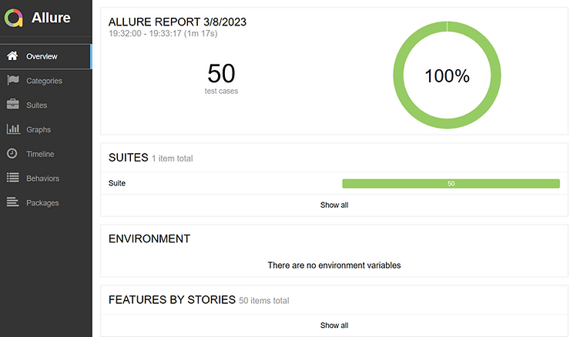

**2. Graphs**

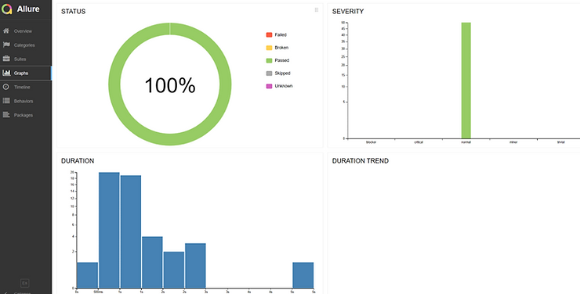

**3. Categories in Allure Report**

The categories tab gives you a way to create custom defects classifications to apply for test results. There are two categories of defects – Product Defects (failed tests) and Test Defects (broken tests).

**4.Suites in Allure Report**

On the Suites tab a standard structural representation of executed tests, grouped by suites and classes can be found.

**5. Timeline in Allure Report**

The timeline tab visualizes retrospective of tests execution, allure adaptors collect precise timings of tests, and here on this tab, they are arranged accordingly to their sequential or parallel timing structure.

**6. Behaviors of Allure Report**

This tab groups test results according to Epic, Feature, and Story tags.

**7.Packages in Allure Report**

The packages tab represents a tree-like layout of test results, grouped by different packages.